
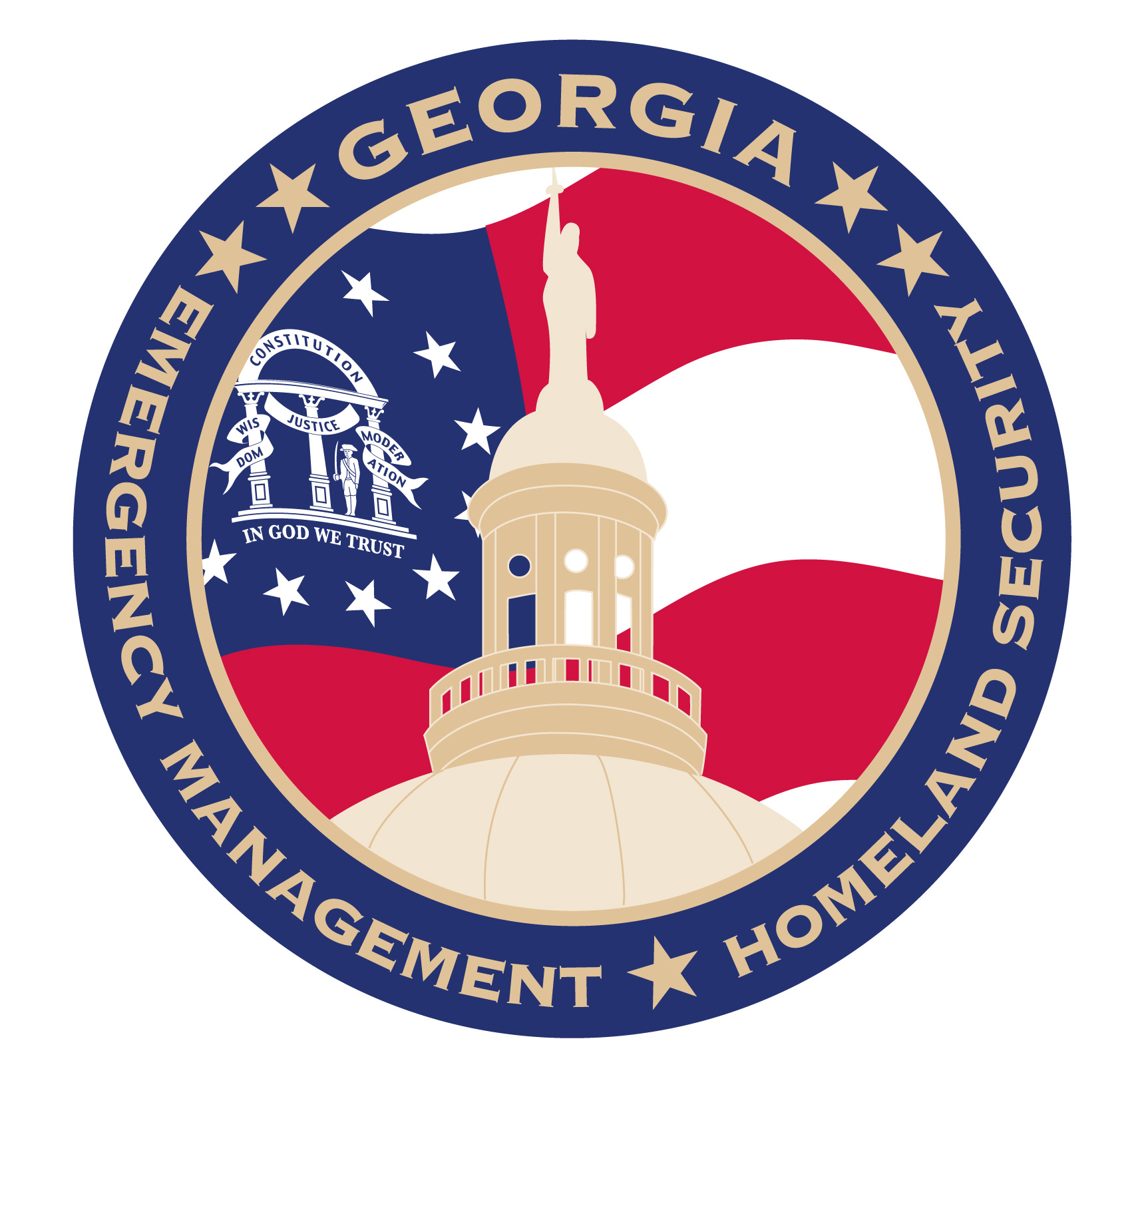

Dear Family,

No one wants to think about the possibility of a fire, tornado or other disaster endangering their loved ones. But preparing for emergencies like these could be one of the most important things you ever do for your family.

As frightening as emergencies can be for adults, they are even more traumatic for children. Equipping your children with valuable knowledge about how to react in various emergency situations and showing them that you have stocked critical supplies can give them confidence that your family is ready for whatever may come your way.

Your child has been learning about the three steps for emergency preparedness:

- Be Informed: Monitor news and weather and identify the potential threats to your community
- Make a Plan: Create an emergency plan for your family, considering how you will contact one another and reconnect if you are separated
- Build a Kit: Make your own Ready kit of supplies, including a three-day supply of water and food, first aid kit, flashlight, batteries and a NOAA weather radio

I encourage you to take a few minutes to talk with your child about what he/she has learned. Take this opportunity to work together as a family to make sure that you are ready for whatever emergencies may come your way.

Ready Georgia, a statewide campaign from the Georgia Emergency Management and Homeland Security Agency (GEMHSA), offers many resources to help you and your family get prepared.

- Create a Ready Georgia profile at www.ready.ga.gov – This online tool provides emergency preparedness information customized just for you, including specific items your family may need following an emergency and a communications plan to help you reconnect with each other if you are separated.

- Download the Ready Georgia mobile app – This free mobile app, available for both iPhone and Android, gives you on-the-go access to your emergency plan and other critical information to help you stay safe during a disaster.

The Ready Georgia website also features games and information for your children, so they can have fun while putting their new emergency preparedness skills to the test.

Please take a few moments to make sure you are Ready. It only takes a little bit of effort and it may be the most important thing you ever do for your family’s safety.

[INSERT TEACHER’S SIGNATURE]

