
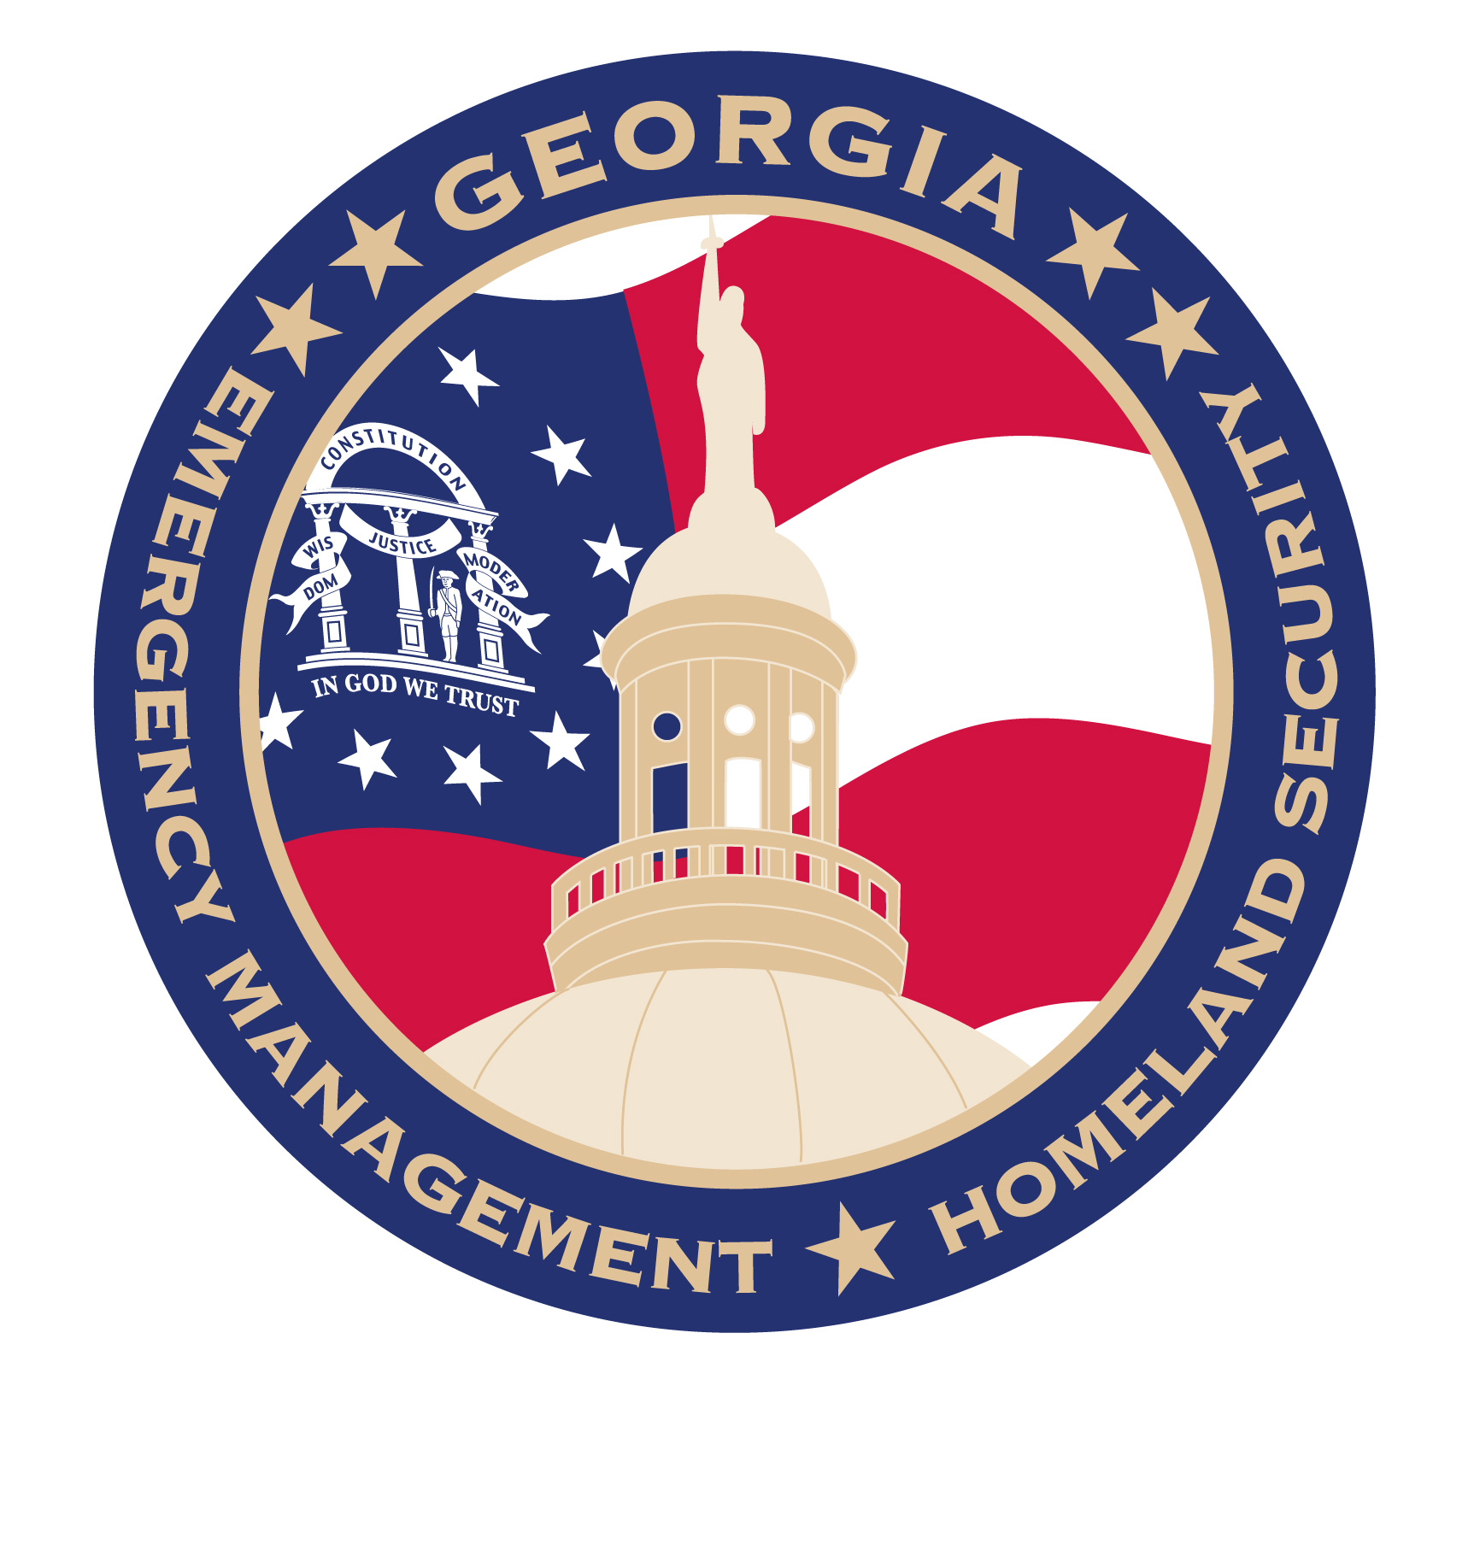

Most Georgians Are Not Ready to Face Disaster. Are You?
The Ready Georgia campaign is helping residents of [Community Name] prepare for large-scale emergencies

Seventy-six percent of Georgians are not fully prepared to survive for 72 hours following an emergency, according to a 2014 survey conducted by the Georgia Emergency Management Agency/Homeland Security (GEMA/HS). In fact, most have not even performed simple tasks like conducting an evacuation or fire drill with their families. A statewide campaign from the GEMA/HS – Ready Georgia –educates and empowers Georgians to prepare for and respond to emergencies.

Ready Georgia uses an interactive website (www.ready.ga.gov) that includes a customizable checklist and plan, community toolkit and public service announcements and advertising to raise public awareness, and on [Date] [Organization Name] will use the campaign’s tools to help the residents of [Community Name] better prepare themselves for a natural disaster, pandemic outbreak or terrorist attack.

Ready Georgia hopes to convey important messages to [Community Name] residents:
- Be Informed – Be informed about the different types of emergencies that could occur and appropriate responses.
- Make a Plan – Create a disaster preparedness plan that includes specific information about how you expect to reconnect with loved ones, evacuate or reach safety. Periodically conduct fire drills and other activities so that a plan will be in place in the event of different types of emergencies.
- Build a kit – Create a Ready kit with items that are inexpensive and readily available at local home stores.

Join [Organization Name] in helping Georgians prepare for emergencies and get ready. [INSERT EVENT DETAILS HERE].

To find out more about emergency preparedness in Georgia, visit Ready Georgia at www.ready.ga.gov.

