Georgia Mitigation Information System (GMIS)

User Guide
GMIS is an on-line mapping tool developed by the Information Technology Outreach Services (ITOS) a Division of the Carl Vinson Institute of Government at the University of Georgia and the Hazard Mitigation Division of GEMHSA. GMIS supports the documentation and implementation of mitigation activities through the State of Georgia through mapping and reporting of Critical Facilities, Mitigated Properties, and National Flood Insurance Program (NFIP) Properties. Currently, critical facilities information is available for querying, information gathering, and reporting.
To meet the Disaster Mitigation Act of 2000 (DMA2K) planning requirements, local governments need to collect detailed structure and building information. This system will enable you to enter information about your community facilities, including coordinates, replacement value, etc. These facilities can then be reported by the hazard zones they fall within. For example, a report is created at the click of a button that shows all facilities that fall within the 100 year floodplain. These reports, along with custom hazard maps, can be imported directly into your mitigation plan to replace “Form #3b: Inventory Assets” from the FEMA How-To Guide #2, page 3-3.

Inputting Critical Facilities/Buildings data into GMIS:

- You must obtain a password and login from a GEMHSA Hazard Mitigation planner

- Login to the system by going to the following website: https://apps.itos.uga.edu/GEMA.GMIS/Home/Index. Enter your provided email and password. Don’t forget to check the disclaimer box.

- Once you have logged in, you should see a map of your assigned area and a set of tools above the map typically, you will only see your county’s critical facility information, represented by red and black points. A black point represents a facility having all of the required information. A red point represents a facility that has incomplete data. If you have a need to see other county data or the entire state, contact your HazMit Planner.

- To update a facility, first click on “layers” at the top of the map. A transparent list of map layers will appear on the right hand side of the map. Uncheck the “Facilities Status” layer and check the “Facilities” layer.

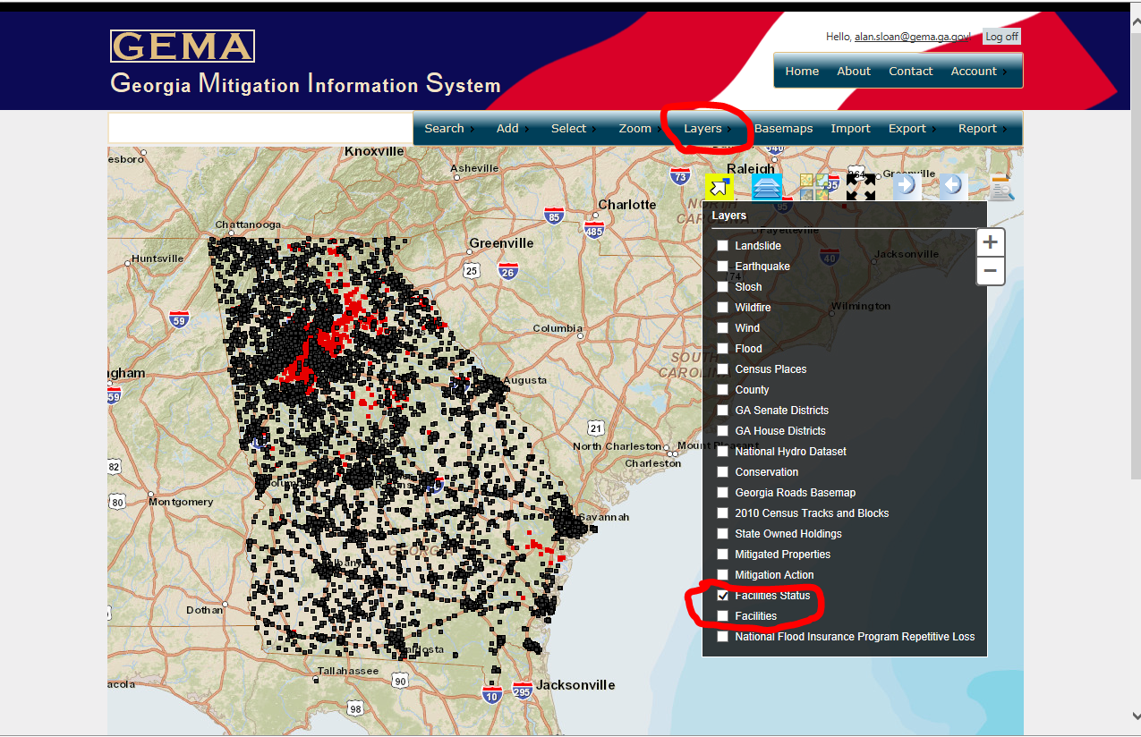

- All of the red and black points will be replaced by blue pins. If you know the location of the facility you wish up update, you can click on that pin on the map. A box with the details on that facility will appear next to the pin. To edit the facility details, click on “edit” within the box.

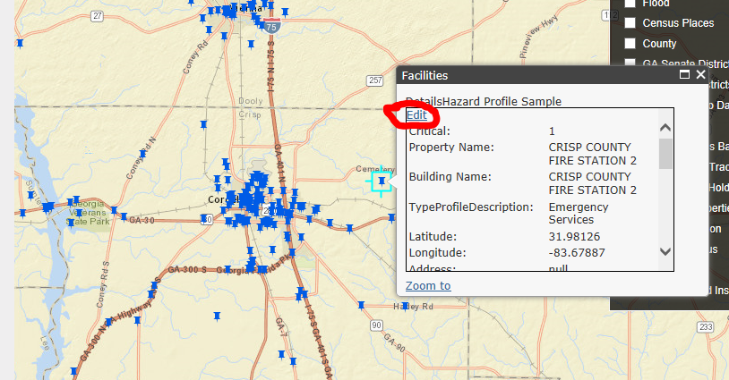

The details of the chosen facility will then appear to the left. Once you have updated the necessary information, be sure and click the “Edit” button at the bottom of the details screen, under the space for the Zip code.

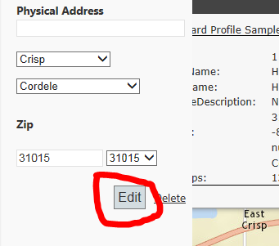

- If you don’t know the location of the facility you wish to update, you can search for it using the “search” tool in the blue toolbar at the top of the map. Click “search” then “facilities.” A menu will appear from the left where you can search the facilities based on a various attributes. We recommend using the name.

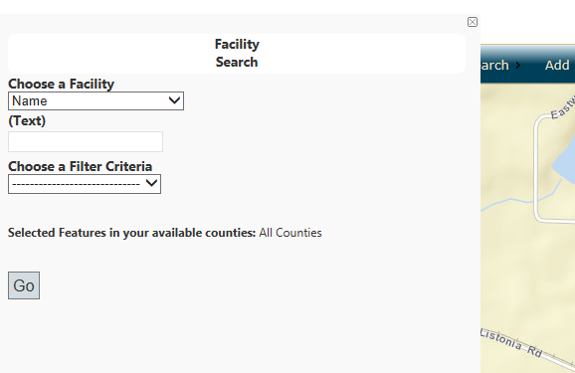

Choose the criteria, whether the name you entered is the whole name or it is the beginning or ending of the whole name. The system will locate facilities matching the criteria you entered and a list will appear on the left. Locate the facility in the list and click on the “edit” icon.

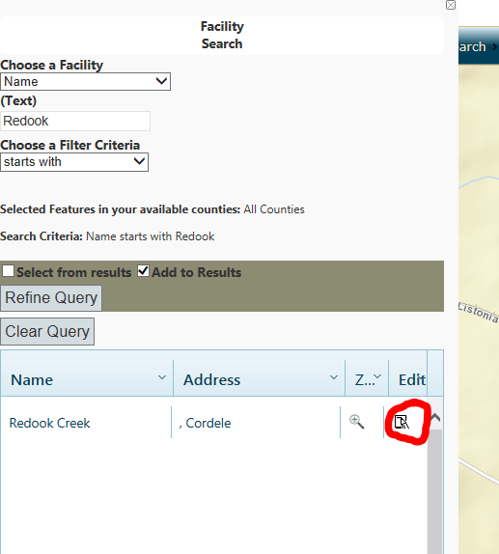

The data screen described above will appear where you can update the facility.

- To add a facility, click “Add”, between “Search” and “Select” in the blue tools bar at the top of the map. Then select “Facility.” A screen will appear from the left with the data fields. The data marked by an “*” is required to save the facility. Data in italics is required to complete the facility and have it included in the reports.

- Once the data screen appears, you can either choose to enter the location coordinates manually if you already know the GPS coordinates or you can click on “Get coordinates from map” if you don’t have the coordinates but can locate the point on the map where the facility is located accurately. (GPS Coordinates Format – Coordinates will need to be in decimal degrees to be entered into the online tool) You must enter the data marked by an asterisk in order to save the facility. Further information for the critical facility/building can be added at a later time using the steps described above for updating facilities.

- The following information is the basic required information necessary to place a facility on the map:

  - Is this a Critical Facility?
  - Building Name
  - Longitude
  - Latitude
  - Jurisdiction
  - Facility Type (two parts)

- Once the minimum required fields are entered into GMIS for the respective facility/building, a red square will be created (In this case not all the minimum requirements for facility/building are entered). In order to identify the building or facility as critical or essential the following information must be provided, which will then change the red square to black, indicating the data is complete: .

  - Building Value
  - Valuation Year
  - Building Valuation Type
Occupancy Code
- Feel free to include any other information as needed.

Bulk data uploads:

- If you have a large number of facilities, there is an option to upload all facilities at once. Click on “import” in the blue tool bar. A new menu will appear from the left. Click on “Bulk Load Template” to download the Excel spreadsheet.

- Once you have filled in the necessary data on the spreadsheet, send the completed Bulk Upload spreadsheet to your GEMA Hazard Mitigation Planner for review and transmission to our GMIS site. We will let you know once the facilities have been imported. NOTE: When using this method, all facilities in the county will be replaced with the new data.

Including the inventory in your plan:

As part of the planning process, you will be required to include the critical facilities inventory in your plan document. This is a two part process. One part is to include a copy of the maps created on the GMIS system. The second part is to include a critical facilities report, also created on the GMIS system.

Maps:

Follow the steps below in order to create maps:

- Log into the system. It should automatically zoom into your county. If it does not, or if you need to zoom in closer or out farther, place your pointer in the center of the point on the map that you wish to zoom to. Then, use the scroll wheel on your mouse to zoom in or out. The map will automatically center itself on you pointer as it zooms. Or, you can double click on the map and it will zoom in toward that location.

- Above the map, in the blue tool bar, click on “layers.” Place a check mark next to the elements you wish to display in the map. For example, if you are looking to map flood plains, place a check mark in the box next to “Flood.” Flood plains should now show up on the map. Click “layers” again to make the list of map layers disappear. Then click “legend” under the “layers” tool. This will place a legend on the map. See the graphic on the page below.

- Once you have your map created, there are two ways to copy the map into your document:

  - One option is to use the Windows Print Screen function by pressing “Ctrl” on your keyboard and, while holding that button, press “Print Screen.” This will allow you to paste an exact copy of what is on your screen into your plan document. If you have the Window’s Paint accessory, or another photo editing software, you can paste the picture into that and edit out any portions of the picture you don’t want included in the plan document.

  - Another option that is available on more recent versions of Windows is the snipping tool. The icon looks like this: 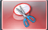. Click on this. When the tool opens, use your mouse to draw a box around the area you want included in your map. The tool will create a picture of that area, which you can copy and paste into the plan document.

- Depending on the hazard, you may need to create individual maps for the municipalities and, if one exists, universities that participated in your planning process. To do this, simply zoom into the area that you want to focus the map on and follow the same process above for creating, copying and pasting the map.
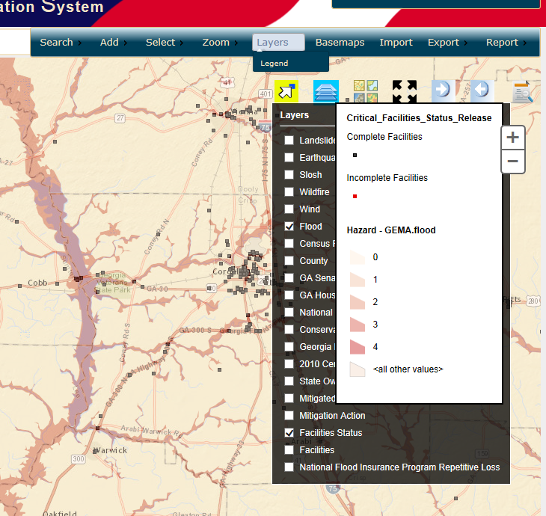

Reports:

- To run a critical facilities report, in the blue tool bar above the map, place your pointer on the word “Report.” Four options should appear. Click on “Facilities.” A menu should appear to the left of the map.

- Use the drop down menu under “Select a hazard” to choose the hazard you are reporting for. Once you select you hazard, you can click the “Go” button. This will create a report of all of the facilities you have access to under the account you are using.

- Once the report has appeared, click the “Download CSV” button at the top. This will download the data into Excel. The data will need to be sorted by jurisdiction then by hazard score. The GEMA planning staff has created an Excel template to help with this. The template will likely need to be modified to fit your data. If you have any questions on it, please contact your GEMA planner for assistance.

Running reports on selected facilities:

Occasionally, it may be necessary to create a report on only a select few facilities, whether based on geographic location, types of facilities, etc. The facilities you wish to report on need to be selected. There are various ways to do this, depending on the need.

- Some users may have access to multiple counties under one account. In order to run reports on only one county, the easiest way would be to place your pointer on “Select” in the blue toolbar at the top of the map, then click on “facility.” A menu will slide in from the right. Click on “By County” and click on “ok” in the pop up box. Then click anywhere on the map inside the county you wish to report on. This will select all of the critical facilities within that county.

- There may be times where it is necessary to report on facilities that meet a certain description. To do this, highlight “Search” in the blue toolbar and click “Facility Details.” A menu will slide in from the left. Click on the drop down menu under “Choose a Facility.” From there choose the criteria you want to use to select your facilities. Then follow the remaining steps as they appear. For example:

  - If you wanted to select all of the water/sewer facilities, choose “Facility Type,” then in the next drop down menu that appears, choose “Water/Sewer.” This would select all water/sewer facilities in the areas you have access to.

  - If you wanted to select all facilities with a certain name, choose “Name” in the first drop down menu. Then, in the box that appears below that, type the name, or at least the beginning or ending of the name, then in the drop down menu that appears, choose whether what you typed is the whole name or the beginning or end. This will select all of the facilities in your area that match the name you searched for.

Follow the steps above for running reports with two exceptions. In the third step, when the menu appears from the left, make sure to select the box next to “selected only.” All the other steps for creating a report will be the same.

GEMHSA Mitigation

Data Collection Guidance

There are multiple data elements that the GMIS system calls for. Some are required to identify the facility as critical, while others are optional, additional information items you may wish to include. The following is a list of each of the items. Items that are required are marked by an asterisk. Some items may have a different name on the GMIS data collection spreadsheet. Where that is the case, that name is included in parentheses.

Is this a critical facility? * (Critical)
A facility is deemed critical if it is vital for the provision of basic services to the community, or the potential loss or community impact would be significant if the facility were to be heavily damaged.

Building Name * (Name)
For existing facilities, verify that the name is correct.

Longitude *
The Longitude value is in “Decimal Degrees.” This can be determined using a Global Positioning System (GPS) device; however, many of today’s mapping programs can be used to determine coordinates. This is particularly good if the program includes aerial or satellite photography, which can be used to locate the building. This number will be negative.

Latitude *
The Latitude value is in “Decimal Degrees.” This can be determined using a Global Positioning System (GPS) device; however, many of today’s mapping programs can be used to determine coordinates. This is particularly good if the program includes aerial or satellite photography, which can be used to locate the building. This number will be positive.

Jurisdiction *

The government entity where the facility is located. We need this information in order to satisfy FEMA’s requirement to report facilities hazard exposure by jurisdiction. This will also help develop mitigation projects, which must be applied for by the governing jurisdiction.

Building Value * (value)
This is the estimated building value, not including contents.

Valuation Year * (valueyear)
Year that the building value estimate was done.

Building Valuation Type * (valuationtypeid)

The valuation method used to determine the value of the building. This will always be the replacement value of the structure.

Facility Type *
This element is broken into two types: An overall facility type, followed by more specific types of facilities. For example, an overall type of facility would be Education, where the more specific types might be K-12, VoTech or University. The types are listed below:

Facility Type *(FacilityTypePrimaryID)
- Education
- Law Enforcement
- Emergency Services
- Government
- Medical
- NGO – This stands for “Non-Governmental Organization” and includes all private and non-governmental nonprofit organizations.

Facility Type Specified *(FacilityTypeNodeID)
- University
- K-12
- Private
- Day Care
- Pre K
- VoTech
- Jr. Colleges
- Police
- State Patrol
- Sheriff
- Marshalls
- Jails
- Prisons
- Penitentiary
- EMS
- Fire Fighters
- EMA
- Court House
- Government Offices
- Water/Sewer
- City Hall
- Library
- Transportation
- Landfill
- Hospital
- Medical Offices
- ALF – Stands for Assisted Living Facility
- NH – Stands for Nursing Home
- Clinics
- Non-Profit
- Communications

Occupancy Code *
Choose one of the following occupancy types. This is based specifically on how the facility is used.
- Agriculture Facilities and Offices
- Retail Trade
- Wholesale Trade
- Personal and Repair Services
- Professional/Technical Services
- Banks
- Hospital
- Medical Office and Clinic
- Entertainment & Recreation
- Theaters
- Parking Garages
- Grade Schools and Admin. Offices
- Colleges and Universities
- Government - General Services
- Government - Emergency Response
- Heavy Industrial
- Light Industrial
- Food/Drugs/Chemicals
- Metals/Minerals Processing
- High Technology
- Construction Facilities and Offices
- Churches and Non-Profit Organizations
- Single Family Dwellings
- Manufactured Housing
- Duplex
- 3 to 4 Units
- 5 to 9 Units
- 10 to 19 Units
- 20 to 49 Units
- > 50 Units
- Temporary Lodging
- Institutional Dormitories
- Nursing Homes
- Unknown

Location
For existing facilities, you will need to verify the coordinates (Latitude and Longitude).

Address 1
Physical street address of the facility.

Address 2
P.O. Box or mailing address of the facility.

City
Street address city.

Zip
Five digit zip-code.

FIPS
This is an identification number assigned to each county. The format is 13xxx, with the “xxx” replaced by the county’s 3 digit FIPS code. This is only needed for the data collection spreadsheet.

Daytime Occupancy
Estimate of the number of people in the building during normal business.

Night Occupancy
Number of people in the building outside normal business hours and/or overnight.
FFEThis is the elevation of the lowest usable floor of the facility. This does not include crawl spaces or open, unfinished storage areas under a structure.

Number of stories
This is the number of finished floors for the facility.

Year Constructed
The year the building is built. This is used to determine what building codes and standards were used.

Area Sq Ft (area)
This is the area, in square feet, that is finished space in the building.

Functional Use Value
This estimate represents the value of the building’s use or function that would be lost if it were damaged or closed due to a hazard event or disaster. A standard way to calculate the monetary damage from losing public functions is to use the budget of the service as a proxy for its value to the community. For private functions, the table on page 3-12 in FEMA How-To #2 Understanding Your Risks shows the average annual sales or production based on square footage. Use ballpark estimate using best available data.

Displacement Cost Per Day
The displacement cost is the dollar amount it would cost for the function (business or service) to be relocated to another structure because of a hazard event or disaster. These costs include rent for temporary building space per month, one-time displacement costs to set up operations in the new space, lost rent per month from all tenants and other costs of displacement. For example, a total monthly operating expense cost of $30,000 would equal $1,000 per day displacement cost, assuming a 30 day month. Use ballpark estimate using best available data.

Contents Value
This is the cost estimate, in dollars, to replace the contents in a structure. Local risk management or building insurance management officials may have detailed records. If local level data sources are not available, use the table on page 3-11 in FEMA How-To #2 Understanding Your Risks to estimate. Use ballpark estimate using best available data.

Contents Value Year
This is the year that the amount used for the Contents Value came from. For example, 2009 (from tax or insurance information)

Contents Description
Provide a brief description of contents if they are unusually expensive or difficult to replace, such as 911 communication equipment.

Risk Type (Critical Facility Type) See below:

Essential Facility
An essential facility is a critical facility that is essential to the health and welfare of the population. The potential consequences of losing functions or services from this type of facility are higher than any other type of structure. Interruption or loss of function from these types of facilities would jeopardize human life and public safety. Essential facilities include but are not limited to: hospitals and other medical facilities, police and fire stations, emergency operations centers, evacuation shelters, schools, and other structures that house first responder equipment or personnel.

Transportation Systems
Transportation infrastructure or facilities. Examples include:
Airways: airports, heliports,
Highways: bridges, tunnels, roadbeds, overpasses, transfer stations.
Railways: tracks, tunnels, bridges, rail yards, depots, switching stations.
Waterways: canals, locks, ports, ferries, dry-docks, piers

Lifeline System
Corridors of flow for equipment, supplies and services. Transportation systems can also be Lifeline Systems. The best physical example of a lifeline would be a bridge and right-of-way that could include utilities and communication. Examples include: potable water, wastewater, oil, natural gas, electric power, and communication.

High Potential Loss Facility
Facilities that would have a high human loss associated with their damage or failure. Examples include: nuclear power plants, dams and military installations.

Hazardous Materials Facility
Facilities that produce or house industrial/hazardous materials, such as corrosives, explosives, flammable materials, radioactive materials, and toxins. Check to see if your county has a Local Emergency Planning Committee (LEPC) and an existing Hazardous Material listing.

Important Facility
These types of facilities are vital for overall day to day community functions, and ensure full recovery in the wake of a hazard or disaster event. Examples include: government buildings and functions, major employers in the area, bank and financial institutions, non-nuclear power generators, certain commercial establishments such as grocery stores, hardware stores and gas stations, technical schools, colleges, and universities.

Vulnerable Population
Is there a vulnerable human population that occupies the structure that would need special assistance, medical care or other actions before, during or after a hazard event or disaster? Examples include: elderly people, jail populations, hospitals, nursing homes, day care centers, people with mental, physical or mobility problems, and non-English speaking populations.

Economic Asset
Larger economic assets that are vital to the prosperity of the community. Examples include major employers and financial centers in your community or area that impact the local or regional economy if significantly disrupted.

Special Consideration
High-density areas (residential or commercial development), if damaged or impacted in a hazard event or disaster, could result in high death tolls or injury rates. Examples include: larger factories or industries, large vertical apartment or housing complexes.

Historic Consideration
Historic, cultural or natural resources, including structures and areas that are identified and protected under state or federal law. Examples include: state parks, federal parks, museums and historic districts.

Other Facilities
Any other significant locally identified facility that does not fit into another category of those listed above. A very brief description should be noted in the “Other Details” field.

Structural Type
Choose one of the following types of structure.

- Concrete Moment Frame
- Concrete Shear Walls
- Concrete Frame with Unreinforced Masonry Infill Walls
- Manufactured Housings
- Other Building Type
- Precast Concrete Tilt-Up Walls
- Precast Concrete Frames with Cast-in-Place Concrete Shear Walls
- Reinforced Masonry Bearing Walls with Wood or Metal Deck Diaphragms
- Reinforced Masonry Bearing Walls with Precast Concrete Diaphragms
- Steel Moment Frame
- Steel Braced Frame
- Steel Light Frame
- Steel Frame with Cast-in-Place Concrete Shear Walls
- Steel Frame with Unreinforced Masonry Infill Walls
- Unreinforced Masonry Bearing Walls
- Unknown Building Type
- Wood, Light Frame
- Wood, Commercial and Industrial

Please feel free to contact your GEMHSA Hazard Mitigation planner with any questions.

