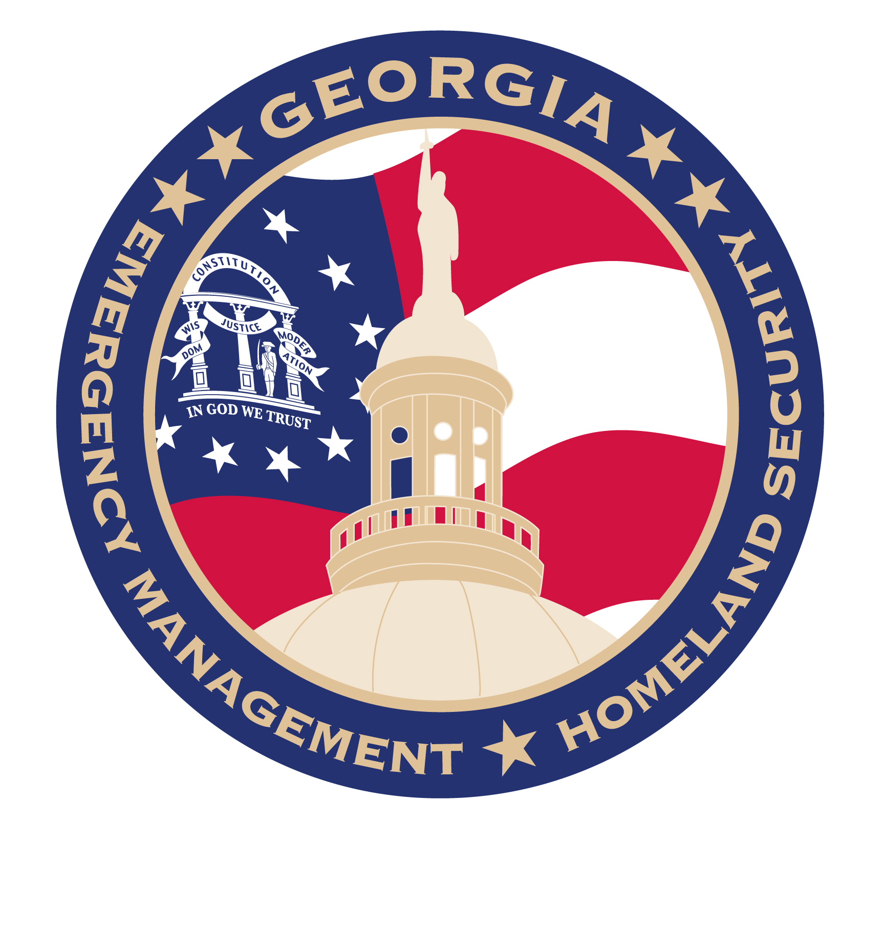
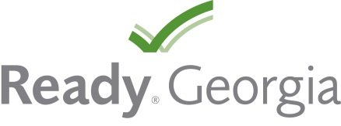

Don’t Put Preparing Off – Make “Someday” Today

Most people admit that it’s important to be prepared for an emergency. According to the latest research, nearly nine out of ten Georgians admit that preparation, planning and emergency supplies will help them handle a large-scale disaster. So why don’t more of us actually get prepared? That same study showed that only 17 percent Georgians have taken the simple but important steps toward personal preparedness.

Unlike many things in our busy lives, being prepared isn’t an immediate necessity. It’s not something that has to get done today. Even if we acknowledge that it’s important, it’s easy to put it off and say that we’ll do it “someday.”

Unfortunately, if we put it off, it’s likely that “someday” will be too late. In the last few years, Georgia has been hit by severe storms, extreme heat, a crippling freeze, deadly tornadoes and dangerous wildfires. For thousands of Georgians, these disasters have resulted in the loss of property and even human life.

Your team at the Georgia Emergency Management Agency/Homeland Security (GEMA/HS) works hard to reduce the negative impact of natural disasters statewide, but it is impossible to eliminate the hazards we face daily. That’s why personal preparedness is so important, and why we’re asking you to make “someday” today by getting ready for disasters now.

You are your own best first responder, so make sure you have the proper tools.

The good news is that many of you have some of the essential items. According to our study, the majority of Georgians say they have a flashlight and extra batteries, a first aid kit and a three-day supply of nonperishable food. However, less than half have a battery-powered radio and emergency resources for family members with functional needs.

In addition to gathering these crucial supplies, making plans for how you will reconnect with family members is also an important step that many Georgians overlook. You may not have access to phones or the Internet in the event of an emergency, so making a plan today can mitigate your risk tomorrow.

To help you figure how to get fully prepared, GEMA/HS and the Georgia Department of Public Health have created the Ready Georgia campaign. Since 2008, thousands of residents have logged onto ready.ga.gov to create a Ready Profile, giving them access to tailored checklists of emergency supplies and customized emergency plans.

Our research also shows that nearly two-thirds of all Georgians believe we have a duty to help each other during an emergency. It is that sense of personal and community responsibility that will allow our state to respond and recover from nearly anything we may experience this year or in the future.

We at GEMA/HS will continue to provide an aggressive approach to preparedness, but no one can respond to your household quicker or better than you if you are prepared. So stop putting it off and make “someday” today.

