Nm12q



­­

Vulnerable Population Evacuation

Transportation Operations Annex

2024

# Approval and Implementation

Transmitted herewith is the updated Vulnerable Population Evacuation Transportation Operations Annex to the Georgia Emergency Operations Plan. This support annex supersedes the Vulnerable Population Evacuation Transportation Support Annex dated 2015 and any/all previous emergency management/civil defense plans promulgated by the State of Georgia for this purpose. It provides a framework in which the agencies of the State of Georgia can plan and perform their respective emergency functions during a disaster or national emergency.

This support annex attempts to be all-inclusive in combining the five mission areas set forth in the National Preparedness Goal: Prevention, Protection, Mitigation, Response, and Recovery. Prevention includes those capabilities necessary to avoid, prevent, or stop a threatened or actual act of terrorism. Protection includes the capabilities to safeguard the homeland against acts of terrorism and human-caused or natural disasters. It focuses on actions to protect our people, our vital interests, and our way of life. Mitigation includes those capabilities necessary to reduce loss of life and property by lessening the impact of disasters. Response includes those capabilities necessary to save lives, protect property and the environment, and meet basic human needs after an incident has occurred. Recovery includes those capabilities necessary to assist communities affected by an incident to recover effectively.

All recommended changes can be submitted in accordance with Annex B of the Georgia Emergency Management and Homeland Security Agency (GEMA/HS) Plans Standardization and Maintenance Policy which might result in its improvement or increase its usefulness. The Vulnerable Population Evacuation Transportation Operations Annex will be revised in accordance with paragraph 6.1.2 of the GEMA/HS Plans Standardization and Maintenance Policy.

# Executive Summary

The Vulnerable Population Evacuation Transportation Operations Annex describes the necessary steps the State will take to prepare and respond to a weather or human-caused incident that requires the evacuation of the at-risk populations (to support county response efforts). It describes the actions taken by the State’s agencies that have been assigned Emergency Support Function (ESF) roles within the Georgia Emergency Operations Plan (GEOP). This support annex is meant to be a guide, in that it allows the State of Georgia to adjust its response based upon the size and scope of the incident. The Vulnerable Population Evacuation Transportation Operations Annex is designed to meet Federal Emergency Management Agency (FEMA) standards, Emergency Management Accreditation Program standards, National Incident Management System requirements, and is compliant with the GEOP. This Vulnerable Population Evacuation Transportation Operations Annex also meets the Americans with Disabilities Act (ADA) requirements to make it accessible under the ADA.

**Table of Contents**

Approval and Implementation iii

Executive Summary iv

Record of Change vi

Record of Distribution vii

1.0 Introduction 1

1.1 Purpose 1

1.2 Scope 1

1.3 Consequence Analysis 1

2.0 Concept of the Operation 2

2.1 General 2

2.2 Plan Activation 3

3.0 General Objectives 3

4.0 Organization and Assignment of Responsibilities 4

4.1 Organization Chart 4

4.2 Primary Agency Assignment of Responsibilities 6

4.3 Support Agency Assignment of Responsibilities 7

5.0 Maintenance and Revision 11

5.1 Evaluation 11

5.2 Maintenance and Revision 12

6.0 Authorities and References 12

6.1 State 12

# Record of Change

|  |  |  |  |  |
| --- | --- | --- | --- | --- |
| **Change #** | **Date** | **Part Affected** | **Date Posted** | **Who Posted** |
|  |  |  |  |  |
|  |  |  |  |  |
|  |  |  |  |  |
|  |  |  |  |  |
|  |  |  |  |  |
|  |  |  |  |  |
|  |  |  |  |  |
|  |  |  |  |  |
|  |  |  |  |  |
|  |  |  |  |  |
|  |  |  |  |  |
|  |  |  |  |  |
|  |  |  |  |  |
|  |  |  |  |  |
|  |  |  |  |  |
|  |  |  |  |  |
|  |  |  |  |  |

# Record of Distribution

|  |  |  |  |
| --- | --- | --- | --- |
| **Plan #** | **Office/Department** | **Representative** | **Signature** |
| 1 | Department of Public Health |  |  |
| 2 | Department of Community Health |  |  |
| 3 | Evacuation Transportation Management and Coordination Contractor |  |  |
| 4 | County EMA |  |  |
| 5 | Georgia Healthcare Coalitions |  |  |
| 6 | Georgia Public Health Districts |  |  |
|  |  |  |  |
|  |  |  |  |
|  |  |  |  |
|  |  |  |  |
|  |  |  |  |
|  |  |  |  |
|  |  |  |  |
|  |  |  |  |
|  |  |  |  |
|  |  |  |  |
|  |  |  |  |
|  |  |  |  |

# 1.0 Introduction

## 1.1 Purpose

The purpose of the Vulnerable Population Evacuation Transportation Operations Annex is to better coordinate the limited number of transportation resources available to support local Emergency Management Agencies (EMA) with evacuation operations of people with functional and medical needs before, during, and following a disaster.

1. Vulnerable Populations: The portion of a population that is subject to the effects of a specific hazard. (At-Risk is a subset of the Vulnerable Population relating to a specific geographic area and typically used for evacuation decisions. Vulnerable Population would include any individuals/groups that are subject to effects because they fall into the Access and Functional Needs or Underserved Populations/Communities.)

2.General public: All who live in, work in, or visit the State of Georgia.

3.Access and functional needs: Populations whose members may have additional needs before, during, and after an incident in functional areas, including but not limited to: maintaining independence, communication, transportation, supervision, and medical care. Individuals in need of additional response assistance may include those who have disabilities; who live in institutionalized settings; who are elderly; who are children; who are from diverse cultures; who have limited English proficiency or are non-English speaking; or who are transportation disadvantaged

4.At-risk populations: Those people who are in a location that will be affected by a hazard as it occurs.

## 1.2 Scope

The Vulnerable Population Evacuation Transportation Operations Annex supports the Georgia Emergency Operations Plan (GEOP) and outlines details associated with evacuation planning, preparedness, response, and recovery. It includes the actions the State will take to support local jurisdictions and the structure in which State resources will operate within.

This plan is intended to be an all hazards plan; however, coastal evacuation operations plan for tropical cyclone threats are the most likely hazards to trigger activation of this plan; Though the timelines may vary, the same approach and concepts of operations should be utilized. Even though this plan is a statewide evacuation transportation plan, the annex includes detailed information for a coastal evacuation due to the scale of the event.

This plan specifically coordinates transportation services to “at-risk” evacuees who are individuals that are either residents at a Long-Term Care Facility (LTCF), Hospital patients, or county residents with functional and medical needs (self-identified in the coastal evacuation registry) who receive transportation assistance through a County Staging Area (CSA). Designated transportation resources will: transport LTCF evacuees to a receiving facility, transport CSA evacuees to a receiving shelter or pre-identified medical facility, and transport hospital patients to another hospital out of the impacted area. State officials intend to implement this plan upon request from authorized county officials in Georgia based on the imminent threat of a tropical cyclone making landfall or on other potential hazards.

## 1.3 Consequence Analysis

The Consequence Analysis located in the current Georgia Hazard Incident and Risk Assessment applies to the Vulnerable Population Evacuation Transportation Operations Annex.

When natural or human-caused disasters occur, the impacts can be devastating and may affect isolated locations or multiple jurisdictions simultaneously.

When the impacts exceed the capabilities of local jurisdictions, the State must respond in a timely, organized, and efficient manner in order to save lives, mitigate property damage, and restore a sense of normalcy to the community. This response is coordinated through the State Operations Center (SOC) in concert with local, state, federal, volunteer, and private sector partners.

The State of Georgia's geographic location makes it directly vulnerable to the impact of tropical cyclones approaching from the Atlantic Ocean and/or the Gulf of Mexico. The State of Georgia is also susceptible to a variety of hazards that can affect Vulnerable populations, and their ability to evacuate if needed.

Lessons learned from past tropical cyclones and other weather-related events reveal that evacuation operations quickly consume the limited number of transportation resources that are required to move certain segments of the population out of the at-risk area. For example, multiple LTCFs and hospitals are often in competition for the same ground transportation resources and are unable to acquire the necessary resources to evacuate all of their residents/patients. Based on these experiences, the Georgia Department of Public Health (DPH) approached the GEMA/HS and requested state planning support with LTCF evacuations. For purposes of this plan, a Long-Term Care Facility refers specifically to nursing homes, assisted living facilities, and hospices.

Likewise, county officials requested state planning support in evacuating residents with functional and medical needs. Local authorities open and operate a CSA in order to assemble and process county residents with functional and medical needs who require transportation assistance during an evacuation.

A person with functional needs is an individual that has physical, sensory, mental health, cognitive, and/or intellectual disabilities affecting their ability to function independently without assistance. These individuals typically reside in single homes or multiple family dwellings in Georgia and are not residents of hospitals, residential health care facilities, or any community-based residences or services that are already subject to emergency planning requirements.

A person with medical needs is defined as a person who is not self-sufficient or who does not have adequate support from caregivers, family, or friends and may need assistance with managing unstable, terminal, or contagious conditions that require observation and ongoing treatment such as: managing intravenous therapy, tube feeding, suction administration; managing wounds; and operating power dependent equipment to sustain life. These individuals require support of trained medical professionals.

# 2.0 Concept of the Operation

## 2.1 General

When an emergency or disaster has occurred or is imminent, the Governor may issue a State of Emergency. This provides the Director of GEMA/HS the authority for the deployment and use of state personnel, supplies, equipment, materials, and/or state owned, leased, or operated facilities to support response and recovery operations.

If a disaster or emergency occurs without the Governor issuing a State of Emergency, then the Director of GEMA/HS is authorized to activate the Vulnerable Population Evacuation Transportation Operations Annex and implement any emergency response actions that may be necessary for the immediate protection of life and property.

During activation of the Vulnerable Population Evacuation Transportation Operations Annex, the SOC will forward all applicable Resource Requests to the appropriate ESFs.

## 2.2 Plan Activation

Plan activation will occur in accordance with GEOP and SOC Activation Concept of Operations located in the GEOP.

General guidelines for plan activation are based on weather forecasts from the National Hurricane Center / National Weather Service and from GEMA/HS leadership recommendations.

# 3.0 General Objectives

The general objectives of the Vulnerable Population Evacuation Transportation Operations Annex are as follows:

* Coordinate the limited number of transportation resources available to support medical evacuation operations of people with functional and medical needs before, during, and following a disaster.
* Assist local DPH with the evacuation and placement of registered, medical and functional access needs citizens.
* Support sheltering operations, as necessary.
* To preserve lives, durable medical equipment, medication, and medical information for our vulnerable population during evacuation and repatriation.
* To schedule workshops with local organizations on evacuation planning for vulnerable populations.
* Review and distribute the Vulnerable Population Evacuation Transportation Operations Annex to Georgia healthcare facilities, District Public Health Departments, Healthcare Coalitions, and local Emergency Management annually.
* Update transportation agreements with contracted vendors annually. This should be accomplished no later than May of each year.
* Conduct annual exercise at the SOC with contracting agencies and transportation providers.

# 4.0 Organization and Assignment of Responsibilities

## 4.1 Organization Chart

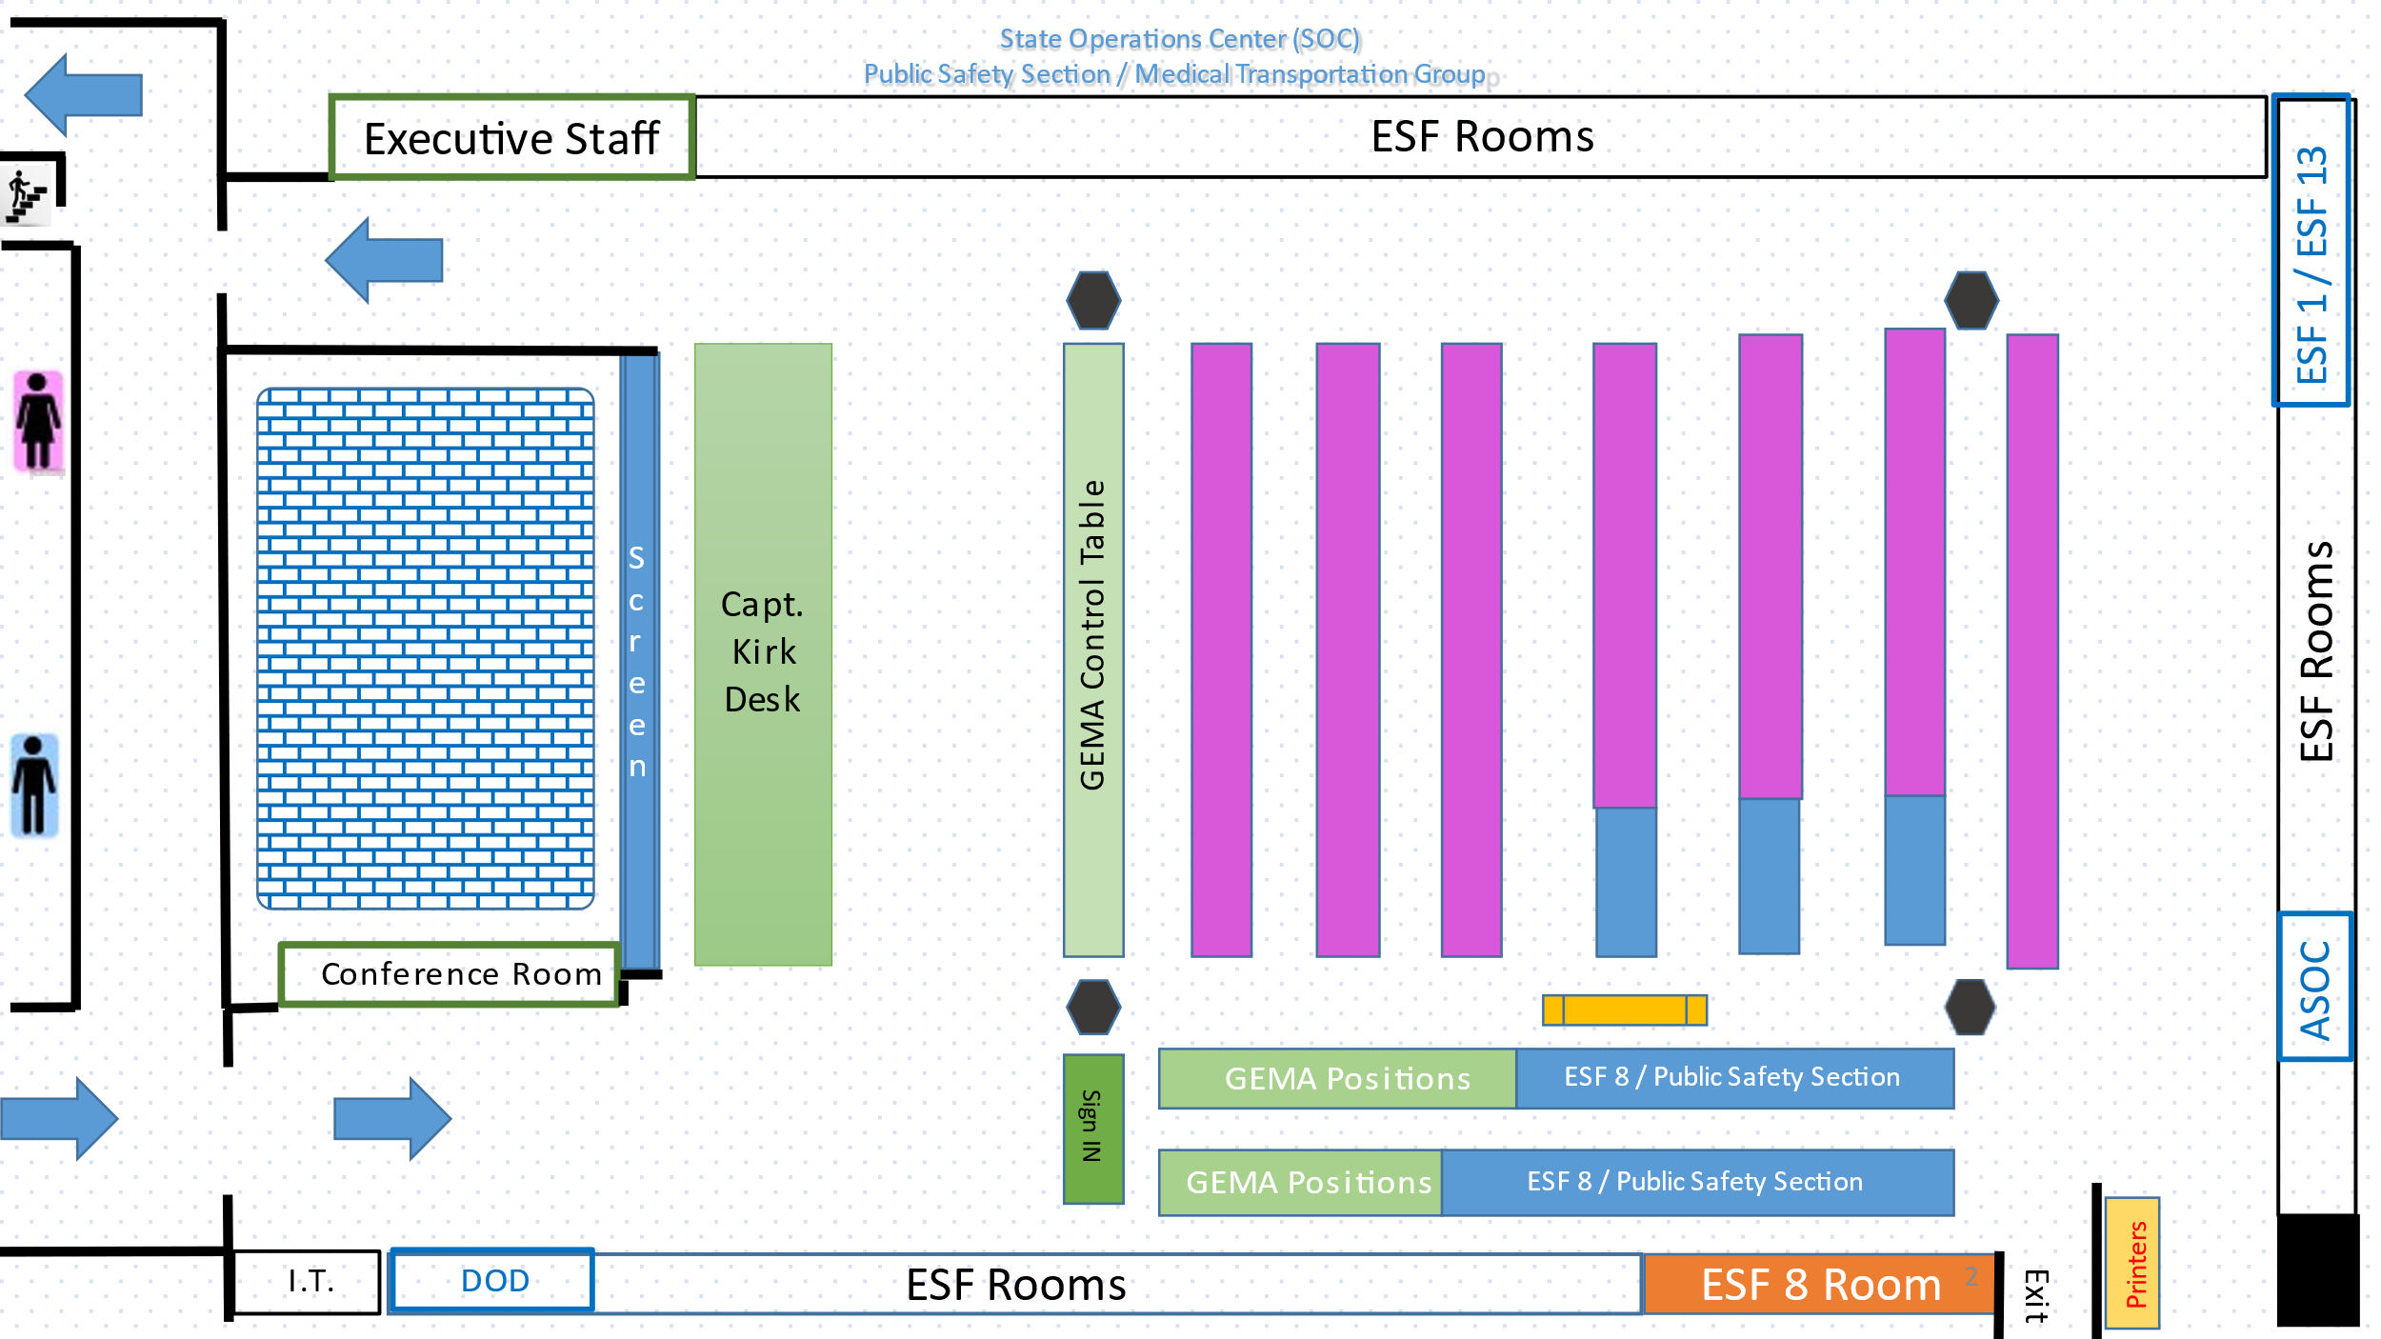

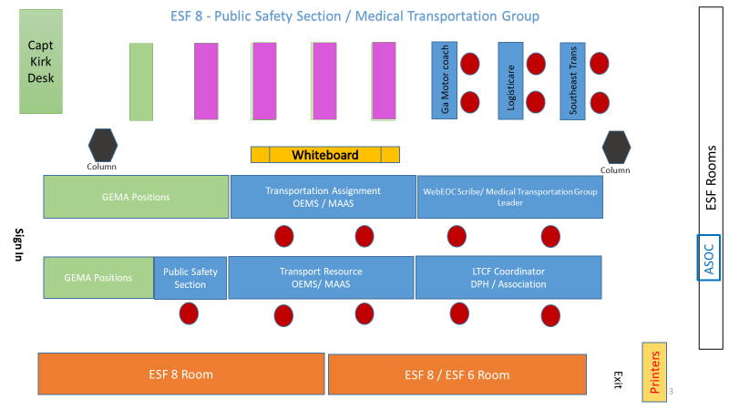

**Transportation Management Group**

* ESF-8 Lead(s)
* Branches (Public Safety – Mass Care – Duty Officers – Volunteer Management)
* Public Safety Branch Director
* Medical Transportation Group Supervisor
* Transport Assignment Unit Leader (Transportation Assignment Desk)
* Transport Resource Unit Leader (Transportation Resource Desk)
* LTFC Unit Leader
  + (LTCF/ Vulnerable Populations Coordinator)
  + Emergency Preparedness Coordinator (GA Healthcare Association)
* Non- Emergency Vehicle Unit Leader
  + GA Motor coach Staff (President & Chief Operator)
  + Regional Transportation Director (Coastal Regional Commission)
  + Southeastern (Verda Inc)
  + LogistiCare (Modivcare)
* During activation, there will be two staff personnel that will be working each 12 hour operational period.

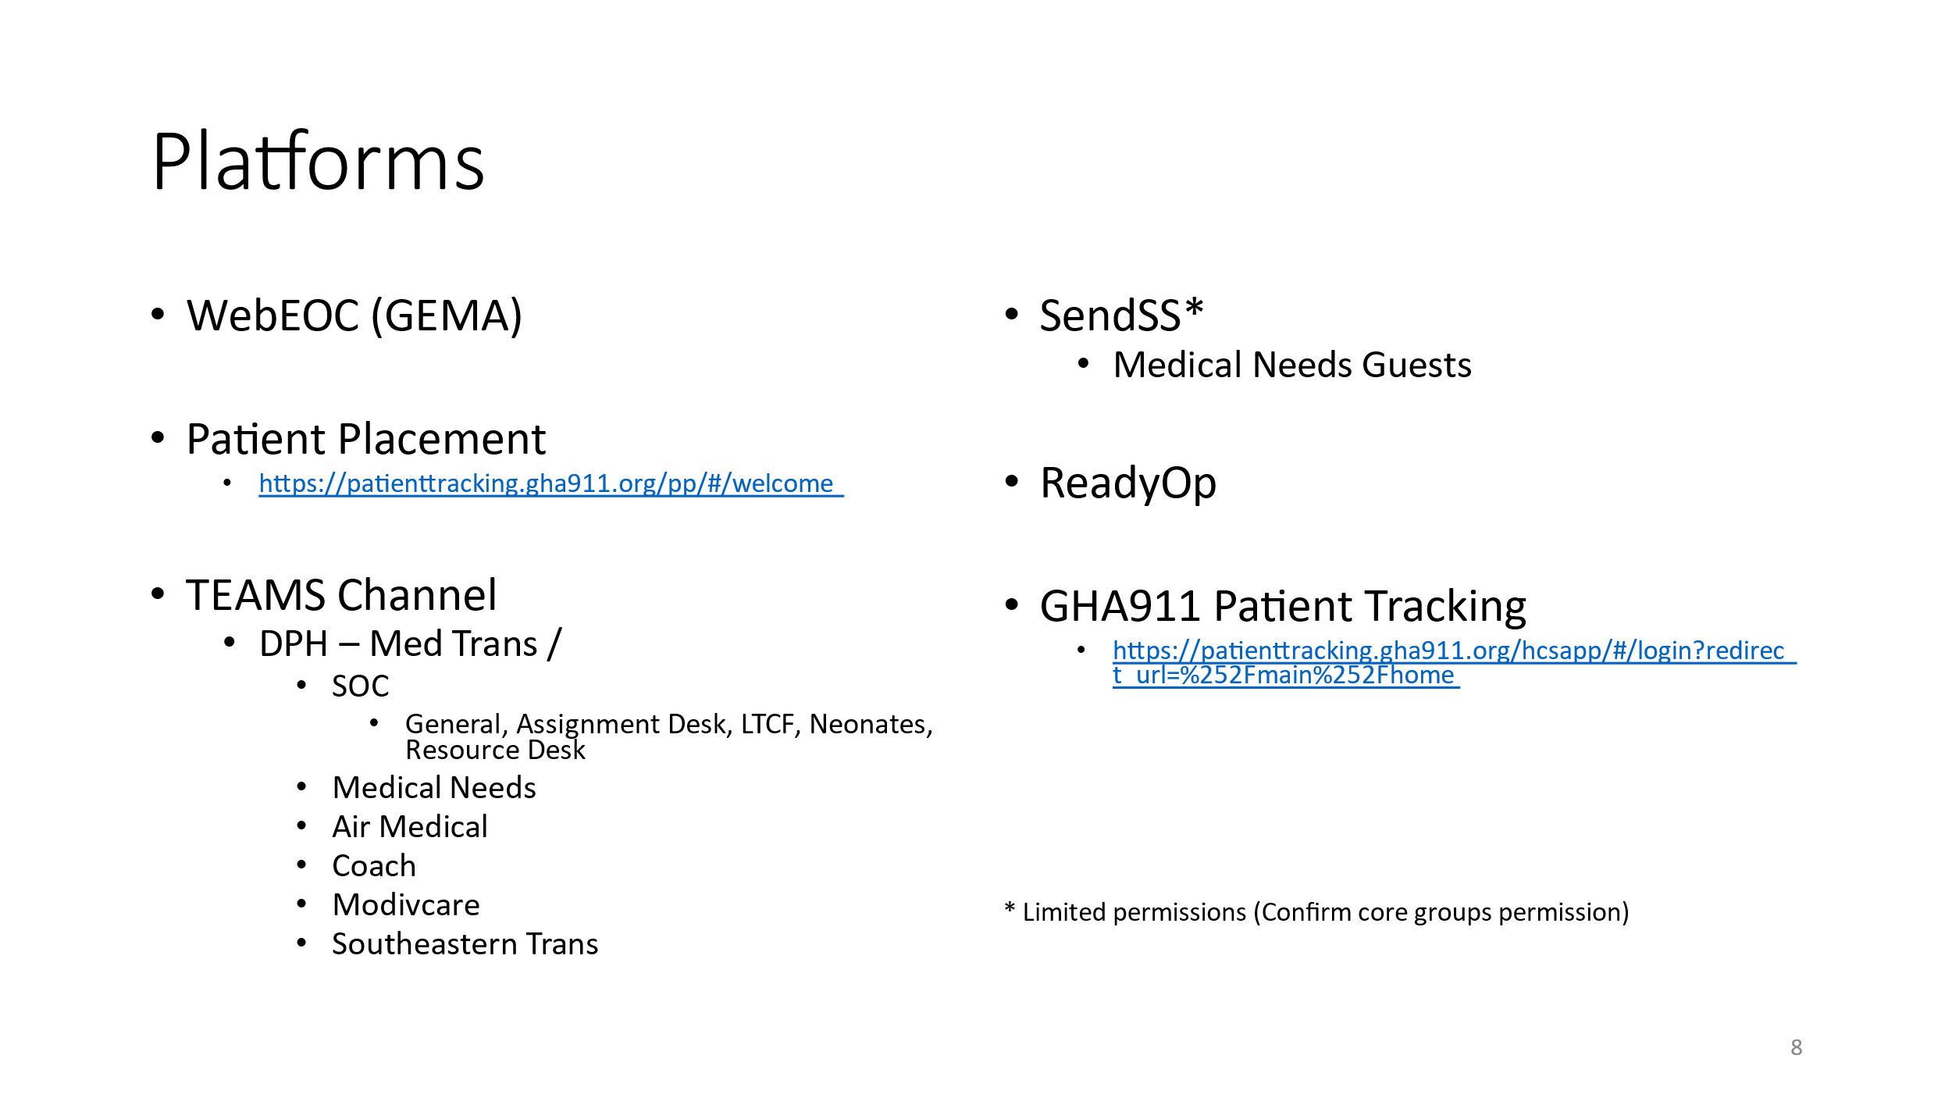**Southeastern Trans is now Verida, Inc.

## 4.2 Primary Agency Assignment of Responsibilities

**Georgia Emergency Management and Homeland Security Agency**

* Following is a list of specific responsibilities related to evacuation planning procedures:
* For purposes of this plan, GEMA/HS’ responsibilities include but are not limited to assisting local emergency management officials, in conjunction with state and local public health officials and other ESF agencies as appropriate. As such, ESF-7, through evacuation logistics, will contract motor coach, para transport and ambulance transport and transportation asset/deployment management augmentation for ESF8 (MTG) in order to assist Counties in their Vulnerable Population evacuation operation.
* GEMA/HS will also activate and manage the SOC. The SOC is a Multi-Agency Coordination Center used by state, federal, volunteer, and private sector partners to coordinate support to local jurisdictions during emergencies and disasters.
* GEMA/HS officials will administer requests for assistance from local jurisdictions and coordinate support to affected counties when an emergency incident exceeds the local government's ability to respond or recover. If local and state requirements exceed state capabilities, then the State of Georgia may request a federal declaration in order to acquire federal support. If the state obtains a federal declaration, then GEMA/HS may request federal support by submitting an Resource Request Form (RRF) to FEMA.

**Georgia Department of Public Health**

* The Georgia Department of Public Health serves as the Coordinator for ESF-8. In partnership with supporting agencies, ESF-8 conducts planning, preparedness, response, and recovery activities.
* DPH’s Office of Emergency Preparedness and Response is responsible for preparing and responding to disasters from a health and medical-related perspective.
* DPH collaborates with 159 County Health Departments, 18 Public Health Districts, and 14 Health Care Coalitions. Designated DPH officials will assume a leading role in coordinating requests for the ground transportation resources required to support LTCF, CSA, Hospitals evacuations, and other ESF-8 medical transportation needs, as necessary.
* The Medical Transportation Group (MTG) also supports other functions and activities during response and recovery activities. The DPH representative to the MTG at the SOC will coordinate closely with GEMA/HS.

**Office of Emergency Medical Services and Trauma (OEMS)**

When activated at the SOC (or virtual location), the OEMS and DPH Emergency Preparedness serve as the ESF-8 Medical Transportation Group Lead. As well as them being Georgia’s regulatory agency for licensed Paramedics and Emergency Medical Technicians, the OEMS also serves as Georgia’s regulatory agency for Emergency Medical Services (both air and ground).

## 4.3 Support Agency Assignment of Responsibilities

**Georgia Department of Community Health (ESF-8)**

* The Department of Community Health (DCH) is responsible for Medicaid Services and healthcare facility regulations. DCH may support the evacuation coordination by assisting DPH and the MTG during and after an event.

**Georgia Department of Human Services (ESF-6)**

* The Georgia Department of Human Services (DHS) is the principal state agency responsible for Mass Care, Emergency Assistance, Temporary Housing, & Human Assistance, including sheltering and feeding services, under ESF-6. DHS is comprised of several departments, offices, and divisions aimed at providing a wide range of human services.
* During an emergency or disaster, the DHS Emergency Manager is responsible for coordinating mass care, housing, and human services in partnership with the American Red Cross.
* For purposes of this plan, the ESF-6 Coordinator/Lead will coordinate with county counterparts, the SOC’s ESF-5 staff, and County EMAs to respond to requests associated with sheltering during an evacuation operation.

**Georgia Department of Agriculture (ESF-11)**

* ESF-11 (Agriculture and Natural Resources) will coordinate the establishment of disaster animal shelters as prescribed in the ESF-11 Annex to GEOP.
* ESF-11 (Agriculture and Natural Resources) will coordinate the transportation of service animals for evacuation with a resource request/mission assignment from the SOC as outlined in the federal PETS Act.
* The MTG will not transport animals unless covered under the specified law outlined in the contract.

**Georgia Department of Transportation (ESF-1)**

* The Georgia Department of Transportation (GDOT) serves as the coordinator for ESF-1 and conducts ESF planning, preparedness, response, and recovery activities;
* GDOT coordinates all requests for assistance for air and ground transportation resources;
* Monitors the transportation infrastructure during evacuations and provides regular reports on traffic volumes;
* GDOT also assists state agencies, local jurisdictions, and volunteer organizations with information and Resource Requests as possible;
* Supports the Transportation Management Group with recommendations for alternate routes during an evacuation.

**Georgia Department of Administrative Services (ESF-7)**

The Georgia Department of Administrative Services is comprised of several divisions including Human Resources, Risk Management, Fleet Management, Surplus, and State Purchasing. The State Purchasing Division (SPD) serves as the central procurement agency for all state government entities. The SPD provides approval and purchase of services, supplies, and equipment required in response to emergency or disaster operations. In response to this plan, the SPD is responsible for assisting GEMA/HS with establishing and maintaining statewide contracts for emergency standby services for: (1) providing transportation management in the SOC and designated state staging areas, if utilized and (2) multiple contractors to provide ambulance(s), para-transit, motor coach, and air medical (fixed and rotor wing), and single resource(s) in support of emergency response activities pertaining to Hospitals, LTCFs, and CSA evacuations.

**Non-Emergency Medical Transportation (NEMT)**

The Department of Community Health administers the Medicaid Non-Emergency Medical Transportation (NEMT) Brokered Services Program through NEMT Brokers who provide NEMT service through private transportation providers throughout the state. GEMA/HS has an agreement with DCH-Medicaid to Contract Brokers to utilize Medicaid NEMT resources and services in the event that a human-caused or natural disaster warrants full or partial evacuations within Georgia. At the request of GEMA/HS, the DCH Medicaid Contract Broker will assign a representative to the SOC. The DCH Medicaid Contract Broker representative at the SOC will coordinate with the Medicaid NEMT Brokered Transportation Providers and offer subject matter expertise and situational awareness to SOC officials, as requested. Upon activation of the DCH Medicaid Contract Broker representative at the SOC in order to maintain situational awareness, Non-Emergency Medical Transportation representatives must provide a tracking mechanism and/or contact information of the transport vehicles dispatched and or transporting under a Medical Transportation Group mission request. This information must be available to the Medical Transportation Group during each operational period.

**Coastal Regional Commission (CRC)**

The Coastal Regional Commission (CRC) manages transportation services for coastal Georgia.

* CRC has an agreement with GEMA/HS to provide limited ambulatory and wheelchair capable population transit in support of evacuation activities.
* CRC shall maintain a communication link with the SOC and coordinate vehicle requirements and movement with staff at the SOC.

**Motor Coach Vendors**

Vehicle contractors for coaches will be selected , all best qualified, using established statewide contracting processes. Contract terms may require contractors to assign a representative to the SOC or state Staging Areas to assist with evacuation coordination.

* Vendors will provide vehicles and drivers in accordance with contract terms;
* Vendors will transport evacuees from assigned locations to designated receiving healthcare facilities/locations.

**Ambulance Vendors**

Ambulance contractors will be selected, all best qualified, using established statewide contracting processes.

* Vendors will provide vehicles and drivers in accordance with contract terms;
* Vendors will transport evacuees from assigned locations to designated receiving healthcare facilities/locations.

## 4.4 Requesting Agency Assignment of Responsibilities

**Requesting Agency**

When GEMA/HS executes the Vulnerable Population Evacuation Transportation Operations Annex, the financial liability falls back to the requesting entities. These entities are required to request for state transportation assistance through the county EMA to GEMA/HS via RRF. The requesting agency will incur financial liability for state transportation resource requests.

## 4.5 Other External Agencies

**County Emergency Management Agencies**

All emergencies are a local emergency and each county EMA is responsible for coordinating all aspects of the county's preparedness, response, and recovery functions associated with an emergency/disaster. In Georgia, county and municipal jurisdictions have the authority to issue an evacuation order. The Georgia Emergency Management Act, as amended, provides the authority to the County Commission or elected authority to order an evacuation when deemed necessary to protect lives. Each local government is responsible for evacuating areas within its jurisdiction and shall establish priorities and regulations regarding the evacuation of residents and visitors. The County EMAs play a key role in the development and implementation of evacuation plans at the local level.

Each County EMA will activate and manage its Emergency Operations Center in response to a situation which merits the issuance of a countywide evacuation order. County EMA officials will coordinate with the SOC if an emergency incident exceeds the local governments’ ability to respond or recover from the incident (Vulnerable Population Resource Requirements). For purposes of this annex, each County EMA's responsibilities include but are not limited to:

* Coordinating ground transportation Resource Requests necessary to evacuate the “at risk” population;
* Ensure local Public Health Department maintains and updates the Functional and Medical Needs Registry;
* Ensure local ESF 8 confirms the status of the residents that are in the registry to determine evacuation requirements;
* Submit Resource Requests for LTCFs, hospitals, and residents on the registry who require transportation;
* Work with county ESF representatives to coordinate county evacuation operations;
* Coordinating public information messaging and dissemination with the ESF-15 External Affairs Joint Information Center.

**Federal Emergency Management Agency (FEMA)**

FEMA is responsible for assisting states with preparedness planning and providing supplemental assistance during an evacuation operation or disaster incident if the resources required exceed local and state capabilities. In response to a state request for federal assistance, the President of the United States may issue a Pre-Disaster Emergency Declaration, making federal resources available to assist Georgia in implementing various emergency operations plans. If Georgia determines that federal assistance is required to implement portions of this evacuation transportation plan, then GEMA/HS will submit RRF(s) to FEMA. GEMA/HS must submit an ~~A~~RRF to FEMA in order to request transportation resources via the federal ambulance contract. If FEMA receives and approves Georgia’s request, then FEMA may issue mission assignments or task orders to fill the request. FEMA may also pre-position certain resources in order to ensure a more rapid response to emerging state requirements.

**National Evacuation Contracts**

FEMA maintains four, evacuation-specific, contractual agreements with private-sector vendors for transportation resources and operational planning support capabilities. FEMA contracts provides varying degrees of support, and transportation assets are only provided through the National Medical Transport and Support Contract or the Air Transportation Support Service Contracts. FEMA can contract for additional resources, if necessary. If commercial transportation is not available, then FEMA can request additional transportation assistance from the U.S. Department of Defense (DoD) and other federal agencies for general population and patient evacuation. DoD, through the National Disaster Medical System, may provide fixed-wing air transportation for patient aero-medical evacuation with available resources when approved by the Secretary of Defense.

**National Medical Transportation and Support Contract**

* FEMA: Activated to help patients and individuals who need assistance evacuating from an area at significant risk or to provide pre-hospital care and patient transport services in a region that is already affected by a disaster.
* FEMA designated a contractor as the sole prime provider recipient of the Federal National Ambulance and Para-transit Support Services contract ("federal ambulance contract"), which provides a full array of ground ambulance, air ambulance, para-transit services, and medical personnel to supplement the federal and military response to a disaster, act of terrorism, or other public health emergency. Upon issuance of a FEMA task order, the federal ambulance contractor will provide the State of Georgia with ambulances, para-transit vehicles, and medical personnel. All equipment and or assets reporting to Georgia will be inspected by Georgia OEMS staff to ensure all equipment and assets meet Georgia requirements. At the request of GEMA/HS, the federal ambulance contractor will assign a representative to the SOC and Vehicle Staging Area (VSA). The assigned representative at the SOC is responsible for providing ambulance/para-transit subject matter expertise and situational awareness to SOC officials, as requested. A representative will be on location at the SOC during established operational periods and will report to the ESF-8 Medical Transportation Group Leader. All dispatch of assets under the Federal Ambulance Contract will be directed by the Medical Transportation Group to the owning entity of the Federal assets by their representative at the SOC. To maintain situational awareness, reports required from the representative on activities under their purview for each operational period include but are not limited to: daily dispatch logs: including times, locations and any other requested information; and patient care reports: must be reported through the State of Georgia process for submission of patient care reports within the timeline defined under the state of Georgia’s rules and regulations and state law related to patient care reports.
* Coordinate vehicle requirements with the assigned representative at the VSA (if GEMA/HS determines whether it is necessary to utilize a VSA upon execution of the plan). The VSA representative is responsible for coordinating with the SOC representative in dispatching federal ambulance contract vehicles from the VSA to designated locations.

**Evacuation Planning and Operational Support for Motor Coaches Contract**

Provides evacuation planning and support use of motor coaches to evacuate the general population in response to Presidentially declared emergencies and major disasters within the Continental United States. This contract provides generalized non-medical evacuation planning for a large-scale motor coach evacuation operations and disaster-specific non-medical evacuation planning and operational support to facilitate the motor coach evacuation CTN (Critical Transportation Need) general population evacuees. This contract does not provide motor coaches. This contract includes or may provide:

* + Activation of Central Dispatch Operations – Command & Control;
  + Crisis Action Planning, if no state plan exists;
  + Contractor evacuation liaison subject matter expert (SME) support at all key motor coach operational sites;
  + Fleet management coordination (deployment of management staff to motor coach operations sites).

If the State of Georgia receives a Pre-Disaster Emergency Declaration, then the State may request federal support in the implementation of this plan. Examples of operational support may include deploying Liaison Officers (LNOs)/SMEs to key locations, preparing Incident Action Plans, deploying the MTG and providing field support at key sites such as VSAs and VRPs (Vehicle Replenishment Points).

# 5.0 Maintenance and Revision

## 5.1 Evaluation

GEMA/HS conducts all exercises within the structure provided by the Homeland Security Exercise Evaluation Program (HSEEP). ESFs will participate in all exercise activities when applicable and will follow the HSEEP process to include active participation in planning and evaluation meetings, workshops, and conferences.

DPH systematically coordinates and conducts event debriefings and compiles After Action Reports for any incident that calls for the activation of all or any portion of the Vulnerable Population Evacuation Transportation Operations Annex. Necessary ESFs/participating agencies shall participate in this process when applicable. After Action Reports will document areas for improvement, resource shortfalls, and corrective action planning requirements which will be incorporated into subsequent updates to the Vulnerable Population Evacuation Transportation Operations Annex, when applicable.

## 5.2 Maintenance and Revision

The Vulnerable Population Evacuation Transportation Operations Annex will be revised in accordance with the GEMA/HS Plans Standardization and Maintenance Policy. In addition, the document shall be evaluated for recommended revisions and corrective measures as an integral part of the Agency Exercise or Event After Action Reports / Improvement Plans, as well as internal reviews that will follow the issuance of any Governor’s Executive Order or passage of legislation impacting the plan.

# 6.0 Authorities and References

## 6.1 State

The authority for the Georgia Emergency Operations Plan is based on Official Code of Georgia, Title 38, Section 3, Articles 1 through 3, known as the Georgia Emergency Management Act of 1981, and is compliant with the National Incident Management System and supports the National Response Framework.

O.C.G.A. § 38-3-1 et. seq. establishes legal authority for development and maintenance of Georgia's Emergency Management Program and organization, and defines the emergency powers, authorities, and responsibilities of the Governor and Director of GEMA/HS. Moreover, the State’s Emergency Services and Disaster Laws require that state and local governments develop and maintain current Emergency Operations Plans to be prepared for a variety of natural and human caused hazards. Executive Orders by the Governor supplement the laws and establish specific planning initiatives and requirements.