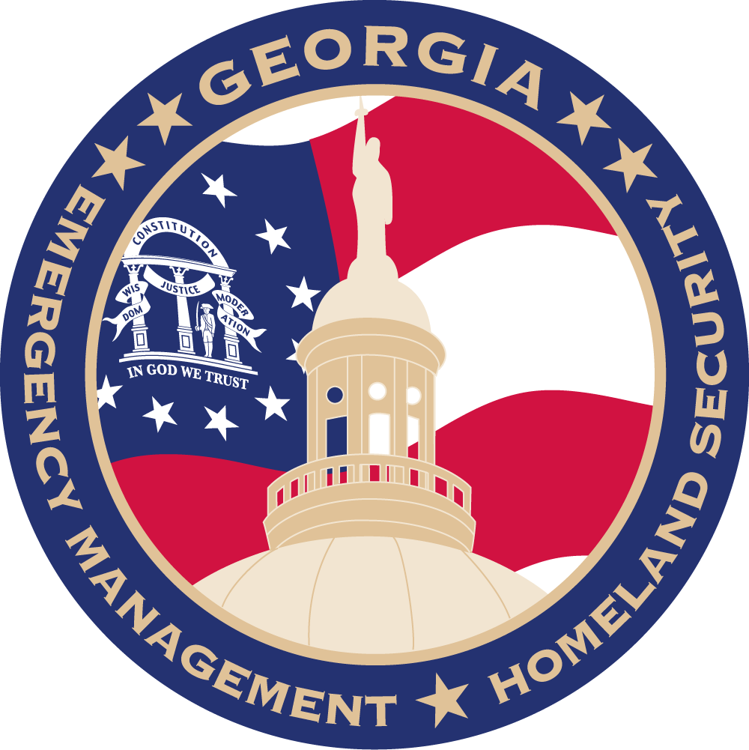
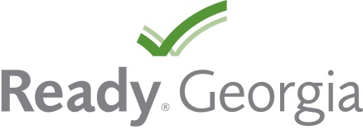

Invest One Hour, Save Three Days
Get Ready Georgia!

When disaster strikes, there’s no time to prepare. With that in mind, it’s critical to invest time now that will save you in the long run. It’s easy to overlook something as important as preparing for a complete unknown such as a tornado, terrorist attack or pandemic flu outbreak in today’s busy environment. But even devoting as little as one hour on the way home from work or on a relaxed weekend can pay off tremendously in a disaster situation.

How? In one hour you can create a Ready kit by collecting items from around your house, like bottled water, canned food, a NOAA weather radio and a flashlight with extra batteries, and placing them in a designated spot. Make a list of what’s missing, and pick them up the next time you’re at the store. [Your Organization Name] is committed to helping its [employees / members / congregation / residents] and wants them to be prepared in the worst cases. That’s why we encourage you to turn to the Georgia Emergency Management and Homeland Security Agency (GEMA/HS) Ready Georgia campaign at gema.georgia.gov/plan-prepare/ready-georgia.

Ready Georgia helps Georgians prepare for the unexpected and wants you to be ready with A Ready kit, a communications plans and pertinent preparedness information. To receive a customized Ready kit checklist and communications plan, visit gema.georgia.gov/plan-prepare/ready-georgia.

